[Grantee or Subrecipient Name]

Section 3 Project Implementation

FORM 6 – SECTION 3 PROJECT COMPLIANCE REPORT

Instructions to complete this form are included at the end of the form.
This form is required for all Section 3-triggered projects (over $200,000) and must be submitted as backup documentation according to the following schedule:

Quarterly  January – March: Due April 10th April – June: Due July 10th  July – September: Due October 10th October – December: Due January 10th | Final  Must cover the entire project from start date to completion date. Final report is due 30 days after completion.

Project Name: | Contractor:
Project Location: | Report Type: Quarterly Final
Reporting Period Start Date: | Reporting Period End Date:

- SECTION 3 CONTACT INFORMATION

Contractor Section 3 Point of Contact:
Phone: | Email:

- SECTION 3 HOURS WORKED – Report the number of Section 3 hours for this reporting period. Attach time records to support the information provided.

A. Total hours worked this period by  all workers | B. Number of Section 3 hours worked this period | % Section 3 hours  (Divide column B by column A)
See instructions below. These are the paid hours reported on the contractor’s payroll forms/documentation.

- TARGETED SECTION 3 HOURS WORKED – Report the number of targeted Section 3 hours for this reporting period. Attach time records to support the information provided.

A. Total hours worked this period by  all workers | B. Number of targeted Section 3 hours worked this period | % Targeted Section 3 hours  (Divide column B by column A)
See instructions below. These are the paid hours reported on the contractor’s payroll forms/documentation.

- QUALITATIVE EFFORTS – If this report indicates numeric goals were not met, attach FORM 4 describing any qualitative efforts made to increase Section 3 participation for this reporting period.

- ADDITIONAL ATTACHMENTS – For the final Section 3 compliance report, attach FORMS 2 and 3 with updated information (versions 2 or 3).

I declare that all statements contained in this form and any accompanying documents are true and correct, and made with full knowledge that all statements given are subject to investigation and that any false or dishonest answer to any question may be grounds for denial or revocation of funding or other penalties as prescribed under 18 U.S. Code § 1001.

Signature: Date:

Print Name: Title: ___________________________________
Instructions for Form 6 – Section 3 Project Compliance Report

Requirement:
This form must be submitted quarterly as backup documentation and at the completion of the project if the (Insert Grantee or Subrecipient) if it is determined the project meets the Section 3 threshold requirements. Contractors and Developers with direct agreements with HCD will submit this form as backup documentation in Grants Network with the Activity Report. Contractors contracted with HCD’s subrecipient, a local government jurisdiction, will submit required forms to the jurisdiction. All construction activity projects assisted by more than $200,000 in HUD funds (for example, CDBG-DR and CDBG-MIT), must comply with Section 3 reporting requirements.

Purpose:
Quarterly reports track total labor hours, total Section 3 labor hours, and total Targeted Section 3 labor hours performed during the relevant quarter.
No obligation to track an employee’s work beyond the project-based employment.
The primary objective of Section 3 is to direct job opportunities (that are generated by HUD financial assistance) to Section 3 workers and Targeted Section 3 workers.
Contractors are required to the greatest extent feasible, to achieve HUD’s Section 3 benchmarks required for the number of labor hours performed by both Section 3 workers and Targeted Section 3 workers:
- 25 percent or more of all labor hours must be worked by Section 3 workers.
  - Section 3 labor hours divided by all labor hours performed on project.
- Five (5) percent of all labor hours must be worked by Targeted Section 3 workers.
  - Targeted Section 3 labor hours divided by all labor hours performed on project.
  - Targeted Section 3 labor hours make up 5 percent of all labor hours performed.

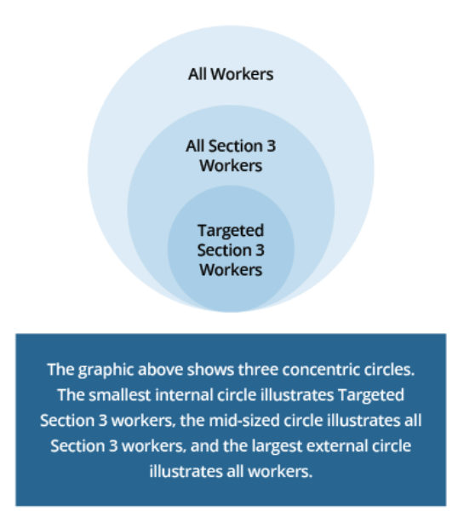
Project and Contractor Information: Please provide as specific project information as possible, indicating the location of construction areas for the project.
Reporting start and end date:

Quarterly reports are due each quarter until the project is completed according to the following schedule for reporting periods:

Quarterly Report Due Date | Quarter | Quarterly Reporting Period
April 15 | One (1) | January 1 - March 30
July 15 | Two (2) | April 1 - June 30
October 15 | Three (3) | July 1 – September 30
January 15 | Four (4) | October 1 – December 31

The final submission of this form, marked final report, is due within 30 days of project completion and must capture the data on this form for the entire project from start (contract execution) to completion date (Final Inspection and Payment).

Section 3 Contract Information: Identify and provide contact information for your Section 3 Coordinator or Section 3 point of contact.

Tracking Section 3 and Targeted Section 3 Labor Hours

Form 7 Section 3 Business Outreach and Form 8 Section 3 Worker Outreach provides the criteria involved to determine the Section 3 status of businesses and workers.

Tracking Section 3 labor hours aligns with tracking labor hours for payrolls systems (time and attendance system) when contractors pay employees based on an hourly wage.
For the purposes of Section 3 labor reporting the following are not required:
- The level of detail of record-keeping that is required under the Davis-Bacon prevailing wage framework.
- Prevailing-wage style payroll reports.
- Software approach to tracking payroll.
What is expected:
- Rely on data from a time and attendance system
  - Identifies Section 3 workers
  - Identifies Targeted Section 3 workers
  - Note: All employees of a Section 3 Business count as Section 3 and Targeted Section 3 workers.
Or,
- Rely on data from any existing salary-based or time-and -attendance-based payroll records can used in good faith reporting.
- Note: For employers who do not track labor hours in detail through a time-and-attendance system, such employers can provide a good faith assessment of the labor hours for a full-or part-time employee.
    - However, if a time-and-attendance system is later implemented, the accurate labor accounting is required.
    - Employers are not exempt if the employer is subject to other time-specific requirements.
  - Employers are NOT permitted to just certify that they have achieved the Section 3 and Targeted Section 3 numeric benchmarks – they must provide some form of supporting documentation of hours worked.

To Calculate Section 3 worker hours: Divide Column B by Column A in the Section 3 Hours Worked table on the form.

To Calculate Targeted Section 3 worker hours: Divide Colum B by Column A in the Targeted Section 3 Hours Worked table on the form.

Qualitative Efforts: These efforts are reported on Form 4. See Instructions included with Form 4.

Additional Documentation/Attachments: For the final Section 3 Project Compliance Report, attach updated Forms 2 and 3. Form 4 is submitted with the final report to describe all efforts made to provide job and other economic opportunities to Section 3 workers.

Signature: Authorized Representative signs and dates form.

