[Grantee or Subrecipient Name]
Section 3 Project Implementation Plan
FORM 8 – SECTION 3 WORKER OUTREACH FORM

Please complete this form to determine if an existing work or potential worker may qualify as a Section 3 or Targeted Section 3 Worker. Instructions to complete this form are provided at the end of the form.

What is Section 3?
Section 3 is a provision of the Housing and Urban Development Act of 1968 (24 CFR Part 75) that requires recipients of certain HUD financial assistance, to the greatest extent possible, to provide job training, employment, and contract opportunities for low- or very low-income residents in connection with projects and activities in their neighborhood.

A worker can qualify as Section 3 if they meet one of the following criteria: (See additional instructions below.)
- Are employed by a Section 3 business concern;
- Are a HUD YouthBuild participant; or
- Their income for the previous or annualized calendar year is below 80% of the current area median income for the area in which the worker resides. (Use the worker’s annual gross income based on AMI for a single-person household.) The State has posted the HUD income limits at State and Federal Income, Rent, and Loan/Value Limits | California Department of Housing and Community Development. Be sure to use the income limits posted in the section titled: CDBG, HOME and NHTF/HHC Article I - Income, Value, Subsidy, and Rent Limits
A Section 3 worker can qualify as targeted Section 3 if they meet one of the following criteria:
- Are employed by a Section3 business concern.
- Are a HUD YouthBuild participant; or
- Reside within one mile of the Section 3 project (or, if fewer than 5,000 people live within one mile of the Section 3 project, within a circle centered on the Section 3 project that is sufficient to encompass a population of 5,000 people according to the most recent U.S. Census);

Worker Information
Name:
Employer Name:
Address:
City: State: Zip:
Phone: Email:

☐ I have reviewed the above information and I MAY QUALIFY as a Section 3 or Targeted Section 3 worker. Please contact me about completing an application.
☐ I have reviewed the above information and I DO NOT QUALIFY as a Section 3 or Targeted Section 3 worker.

Signature Date

Please return completed forms to: (Information to be provided by Grantee or Subrecipient)
Grantee or Subrecipient Name Section 3 Program
Address
City, State ZIP
Phone| Email

Instructions to complete Form 8 Worker Outreach

Workers: If you are a current employee or potential employee, please proceed to Part B below to view instructions for completing this form.

Part A: Contractors/Developers/Subrecipients (local governments):
- Contractors/Developers may complete this form to document Section 3 worker status of an existing or potential worker.
- Review this form for completeness of all entries once the employee has completed the form.
  - Provide the employee with the correct HUD income limits and any assistance necessary to navigate the link to the income limits or an attachment including the income limits.

NOTE: Access to a computer and internet may present a barrier for the employee or potential employee to complete this form. It is highly encouraged that the contractor or relevant employer provide either computer and internet access or make the relevant HUD income limits, per county of residence of the employee or potential employee, easily accessible to assist the individual in completing this form. Employers may provide employees with a range of incomes and then use the employee’s response to compare to the HUD income limits in order to document Section 3 worker verification and satisfy recordkeeping requirements.

- Please reference Form 8 – Section 3 Worker Outreach to view the criteria to verify Section 3 worker status.
- Instructions to navigate HUD income limits and determine a worker’s income are provided below.
  - Ensure the usage of the most recent HUD income limits. Contact the Grantee or Subrecipient (unit of local government) with this request.
- Determine the boundaries of the project service area or neighborhood.
  - Determine if the employee resides in this service area or neighborhood.

Note: Contractors/Developers utilizing this form (Form 8 Worker Outreach) to verify Section 3 status of current employees may use the documentation on file to verify and document the status of workers as Section 3 and Targeted Section 3. Employers may:
- Utilize current salary or estimate of annualized income based on employee’s current rate of pay.
- Verify Section 3 worker status by identifying the worker’s county of residence and documenting if the worker’s annualized pay falls at or below 80 percent of the area median income as determined by HUD.
- Verify Targeted Section 3 worker status by documenting that the Section 3 worker resides in the project service area or neighborhood.
- Measure a one-mile radius around the project site.
  - HUD mapping tool to determine Section 3 service area for project.
- If this one-mile radius does not report population of 5,000, expand the circle until this minimum population number is achieved. See illustration below to demonstrate an example of how the radius around the project area (worksite) is expanded until the circle captures a population of 5,000 persons.
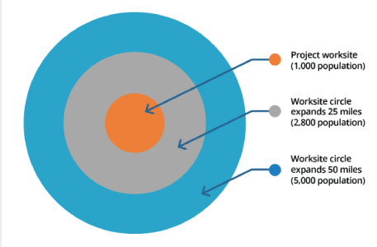

- A worker is a Targeted Section 3 worker if a Section 3 worker (determined by the income limits verification above) documents proof of residence within the established service area or neighborhood.

- Owner Occupied Rehabilitation and Reconstruction Program (OOR): Each individual home project site is the basis to determine the neighborhood area.
- Multifamily Housing Program (MHP): The project is the site or sites together with any buildings(s) and improvements located on the site(s) that are under common ownership, management, and financing.
- Infrastructure Program: The project is the site or sites together with any buildings(s) and improvements located on the site(s) that are under common ownership, management, and financing.

Part B: When current employees or potential employees are asked to complete this form:
Please provide entries for the following information requested on Form 8 – Section 3 Worker Outreach

Worker Information

Name
Employer Name: If unemployed, please indicate so on this line.
Address: Include County of Residence
Phone: Please indicate if you are including the phone number for an individual other than yourself because you do not have personal phone access.
Email: Please indicate if this email address belongs to another individual and that individual will contact you should this method of communication be used.

Selection of Section 3 or Targeted Section 3 worker status on this form

- If you need assistance to complete this form please request assistance from the Section 3 Program Representative from the Developer, Contractor, or local government that is advertising job opportunities and or providing this outreach form.

If you do not have access to a computer and/or the internet, please notify the Developer, Contractor, or local government that is providing this outreach form.

- Check the first box at the bottom of Form 8 if you are employed by a Section 3 Business Concern or you are a YouthBuild participant:
- Please select the first box. By checking the box, you indicate that you may qualify as a Section 3 or Targeted Section 3 worker.
  - If you are unsure as to the Section 3 Business status of your employer, you may contact the employer to confirm. Request assistance from the firm, local government, or individual providing this form.
  - An application process may follow to provide documentation for this determination.

- If you are not employed by a Section 3 Business or hold status of a YouthBuild Participant:
- Please follow the instructions below to navigate the HUD income limits to select if you think you may qualify as a Section 3 worker or Target Section 3 worker.

NOTE: YouthBuild is a community-based pre-apprenticeship program administered by the U.S. Department of Labor that provides job training and educational opportunities for at-risk youth ages 16-24 who have previously dropped out of high school.

Instructions to navigate HUD income limits
Please view the following link to access the income limits for your residential county or metropolitan area: State and Federal Income, Rent, and Loan/Value Limits | California Department of Housing and Community Development. Be sure to use the income limits posted in the section titled: CDBG, HOME and NHTF/HHC Article I - Income, Value, Subsidy, and Rent Limits

NOTE: Income is based on individual income, not total household income, to meet the criteria for a Section 3 worker.

- Open link to the California Income Limits as noted above.

The page will look like the picture below.
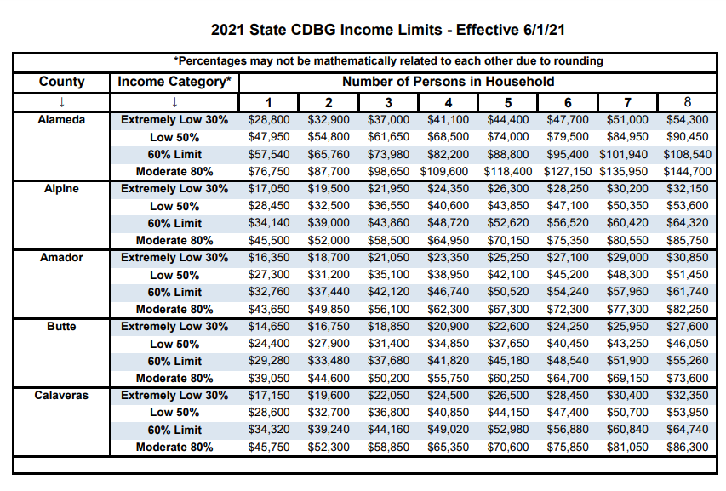

- Scroll down the list to locate the county where you live.

The third row from the top of the page indicates the number of persons in a household. You will only use the column that indicates a household for one (1) person to determine where your income falls within the provided income limits.

- Determine where your income falls within the range of income limits provide for the county where you live.

For example: If you live in Alameda County, follow the income limits provided under the one (1) person household. If your income below the income limit for Moderate 80% in this column for one (1) person household then you are considered to meet the criteria for Section 3 worker status.

If your income falls at or below the income limit for Moderate 80% check the first box at the bottom of form 8 to indicate that you may qualify as a Section 3 worker.

- Determine if you are a Targeted Section 3 Worker.

- The location of the project area will be provided to you by the Contractor, Developer, or local government providing you this form.
- Note: If you are currently employed by the employer utilizing this form (Form 8 Worker Outreach), your address information is already on file and the employer will verify Targeted Section 3 worker status.
- You meet the criteria for Targeted Section 3 worker status if you live within the project site as determined and provided by the Contractor, Developer, or local government and you identify as a Section 3 worker in Question 3 above.
  - Employer will verify Targeted Section 3 worker status.

- Check the second box at the bottom of Form 8 if all of the following statements are true:
  - I am not employed by a Section 3 Business Concern
  - My income does not fall below the Low 50% range on the provided HUD income limits for the county where I live.
  - I am not a YouthBuild participant.

